# GIT

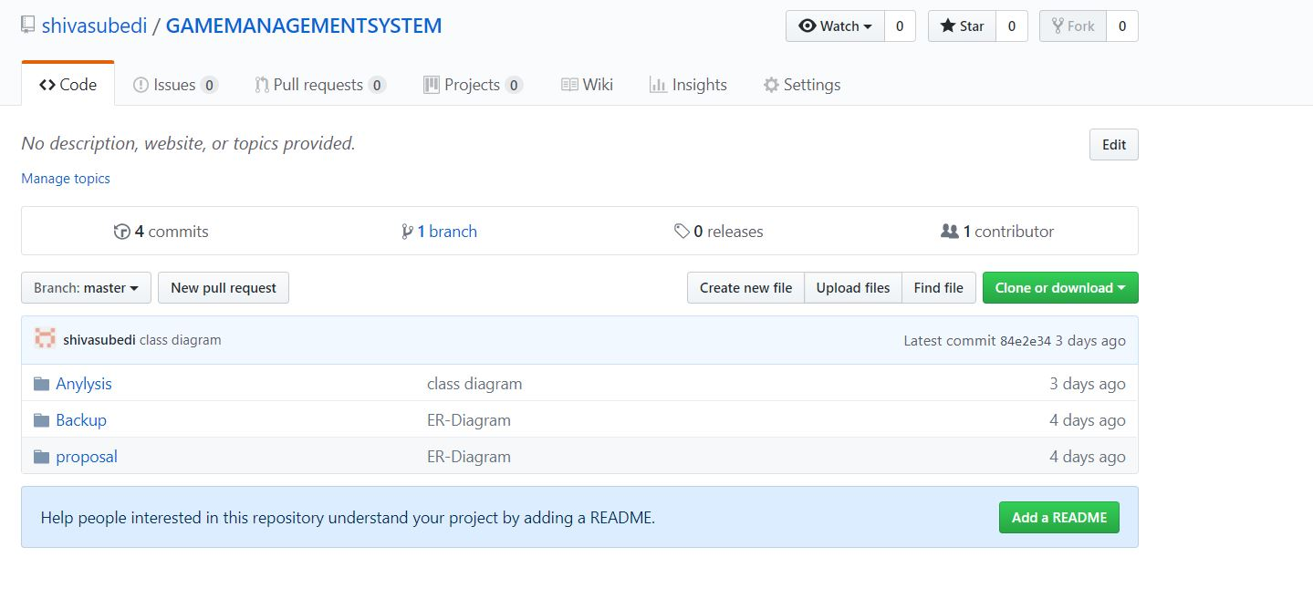

# Use case diagram

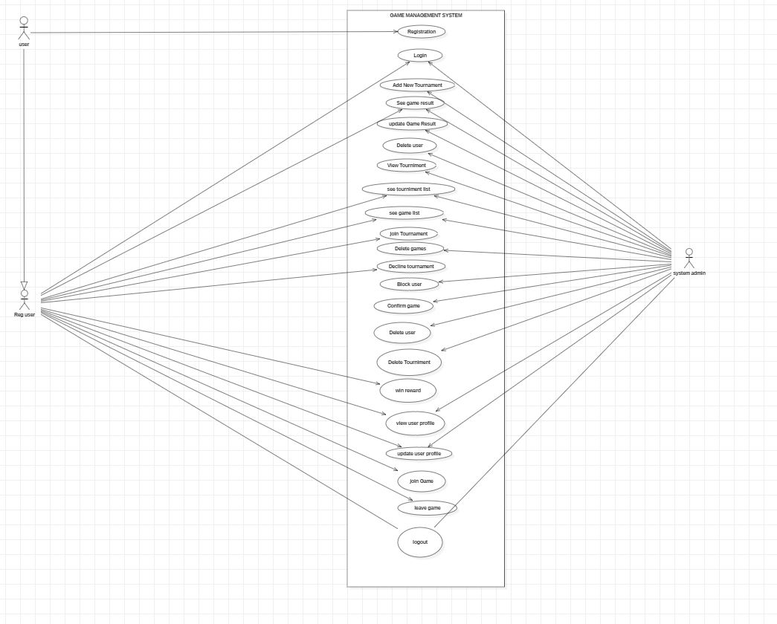

# ER-DIAGRAM

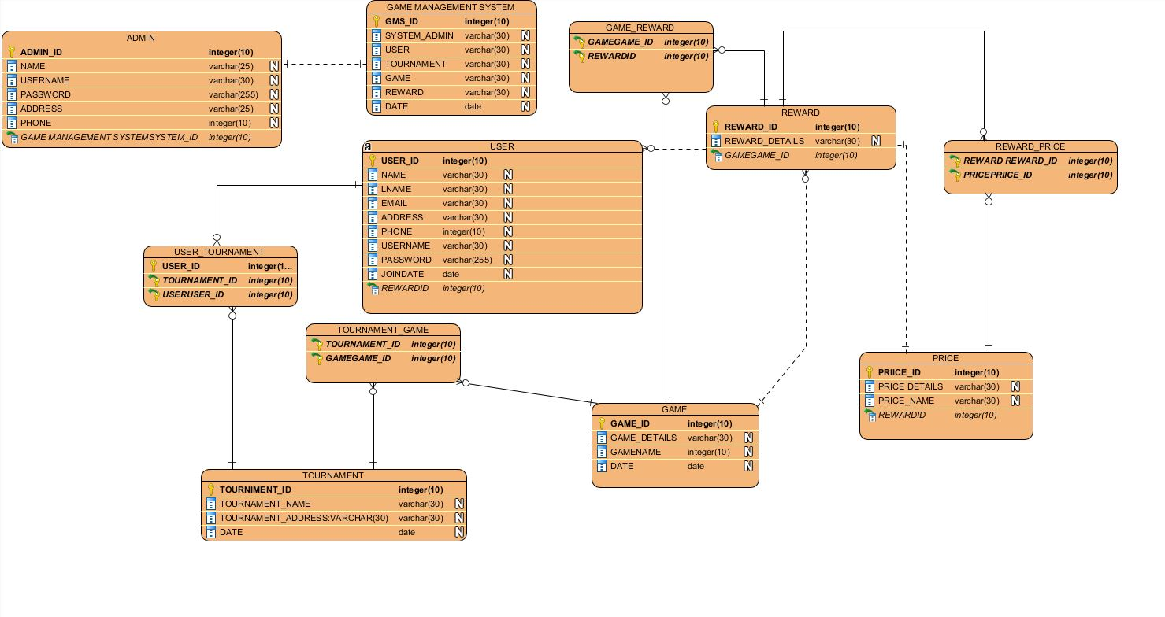

# Initial class diagram

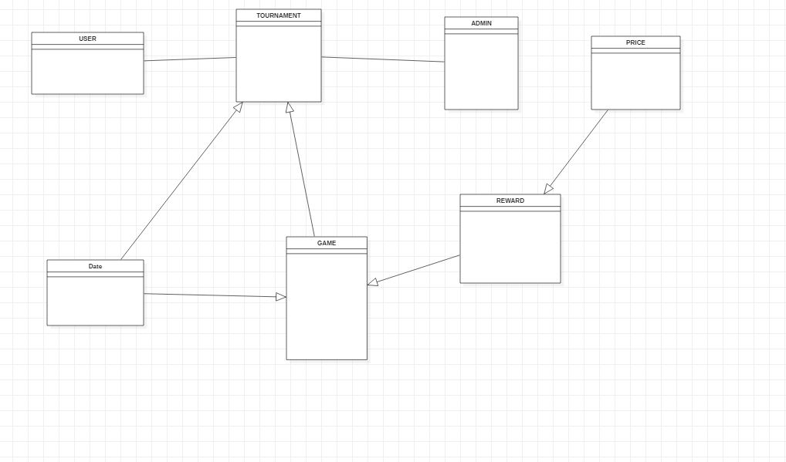

# Class diagram

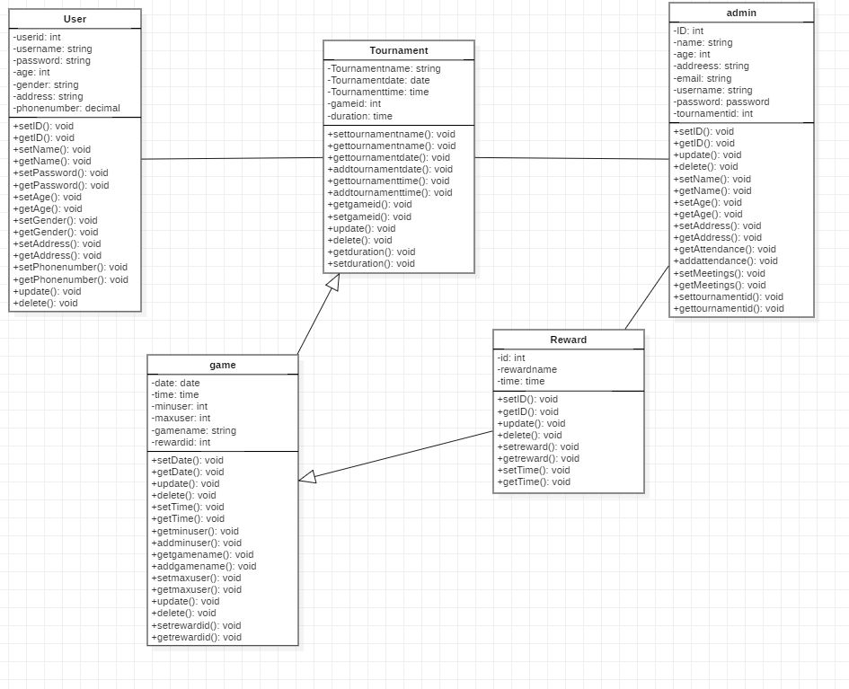

# Requirement functional non-functional for my android program.

|  |  |  |
| --- | --- | --- |
| SN | FUNCTIONAL | NON-FUNCTIONAL |
| 1 | Login user | Update user profile |
| 2 | Login admin | Secure password protection |
| 3 | Add new tournament | Update user profile |
| 4 | Add new game | View admin list |
| 5 | Update game | View reward list |
| 6 | Update tournament | Delete reward |
| 7 | Delete user | Block user |
| 8 | Update user | Secure game |
| 9 | View win user | Delete attend tournament |
| 10 | Delete game | Get payment |
| 11 | Delete tournament | Set payment |
| 12 | Update game time | Delete payment |
| 13 | Update tournament time | User password change |
| 14 | View user list | Upgrade user level |
| 15 | View game list |  |
| 16 | View tournament list |  |
| 17 | View user total win |  |
| 18 | Delete old tournament |  |
| 19 | Win reward |  |
| 20 | Update reward |  |

# UI design

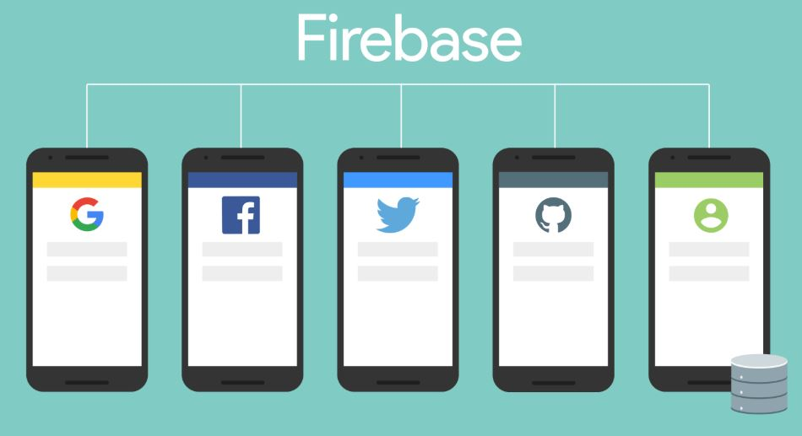a\aq\a\w

